时间 2022年1月7日星期五

写作生词

Depict recipes (口语) articulate starters Conversely instinct noticeable happened

描绘了 食谱 音“瑞色匹s” 清楚地表达 前菜 相反地 直觉 本能 值得注意的是 发生了

in accordance with substantially significantly alleviate surges subsides

按照 实质上地 显著地 v. 减轻 上升 飙升 激增 消退 减退

Benefits and drawbacks

Bottom, eventually, electrical, demonstrate, structure

听力生词

Microbes legality mass widespread

微生物 合法性 大量的 普遍的 广泛的

**Painlessly**  practical considerations stray Elusive atlases

**随便 不痛不痒地** 实际考虑 v. 杂散 走散 n. 离题 流浪动物 a. 难以捉摸的 地图册

Sound postage counterparts pastime plague willingness measures marvelous

a.合理的 完美的 邮费 同行 对方 副本 消遣 瘟疫 困扰 意愿 措施 奇妙 出色 了不起

Pine park chimneys suffocation hindered medics Necessity stale provision journalistic

松园 烟囱 窒息 受阻 医务人员 必要性 陈旧的 条款 新闻的 新闻性 新闻学

slap out promptly Creeks fissures or faults coal-fired power plant Commensurate maternity

拍打 及时的 小溪 裂缝或断层 燃煤电厂 相称的 产妇

Scarce note system marginal cosmetics explode wells implications  hazards

稀缺 笔记系统 边缘 化妆品 爆炸 水井  影响 危害

Stir the interested tuna quite quiet susceptible

(激起兴趣) 金枪鱼 (很) (安静, 比起quite，尾音强调 eeet) 易受影响的 易受感染的

Accommodation self-inflicted Molecular consistent with contamination ingredients

住宿 自作自受 分子 符合 一致 污染 成分

towels exotic aromatic wards disinfectant spray vulnerable

毛巾 异国情调 芳香四溢 病房 消毒剂 喷雾 脆弱的

Pediatrics subtle perceived uneasy inhumane cull instantaneous cope

儿科 微妙 复杂 感知 看作 不安 不自在 不人道 剔除 扑灭 扑杀 a.瞬时的 瞬间的 应对

Adverse art arts Plagiarism stance epicenter debris seismic buoys offshore(离岸) landslide

不利的 美术 文科 抄袭 立场 震中 碎片 杂物 地震的 浮标 近海山体滑坡

Richter scale barrel into barrel anticipation outline elaborate faulty

里氏规模 驶入 冲向 n木桶 v.飞奔 高速行驶 预测 纲要 v.阐述 n.精心制作的 a. 不完善的 不对的

Apparatus journalistic elusive particles Suspicious complaint complain faulty article

器械 新闻性 新闻的 难以捉摸的粒子 怀疑的 可疑的 n. 投诉抱怨 v.投诉怨言 错误的文章 瑕疵品

阅读生词

semi-arid areas gutters debate horrors laid out confabulation gems growth mechanism scrutiny

半干旱地区 排水沟 争论 n. 恐怖的 制定 混淆视听 宝石 (生长机制) 仔细检查imitation pearls imitation versatile appendage auditory hyenas* aphid antibiotics secrete reckless

仿制的珍珠 模仿 仿制的 多功能的附属物 a. 听觉 鬣狗 蚜虫 抗生素 分泌 鲁莽的

Outstrip primitive elaborate edible albeit manufacture manufacturer put right poor service

超过了 超越 原始的 精心制作的 可食用 尽管 n.生产 v. 制造 n 生产厂家 制造商 纠正不良服务

That’s just a **mass** of comparisons of different cultures. 这只是对不同文化的**大量**比较。

It’s the most basic strategy, allowing you to record information at a faster **pace**.

这是最基本的策略，使你能以更快的**速度**记录信息。

The final question is why do we care about these **elusive** **particles**?

最后的问题是，为什么我们要关心这些**难以捉摸**的**粒子**？

The map and chart below show the information for the global **willingness** to eat insect products and the current price for certain food available on the market place.

下面的地图和图表显示了全球**愿意**食用昆虫产品的信息，以及目前市场上某些食品的价格。

That’s a sound(合理的) approach. 这倒是个好办法/这是一个合理的方法

And, of course, there is a good selection of anti-virus software available on the market now as well as on the Internet to combat the virus plague. 当然，现在市场上以及互联网上有大量的反病毒软件可供选择，以对抗病毒的困扰。

The biggest problem is the way eating this meat is **perceived**. 最大的问题是人们对吃这种肉的看法。

the Earth’s temperature **surges** and **subsides** naturally. 地球的温度自然**上升和下降**。

Ginger became extremely popular because of its **exotic, aromatic** properties and was highly valued by spice **traders** in the 17th and 18th centuries because they were able to sell it back in Europe for a very good price.

由于生姜具有**异国情调和芳香**的特性，它在17和18世纪受到香料**商人**的高度重视，因为他们能够以非常好的价格将其卖回欧洲。

And sick people, of course, are very **susceptible**(易受感染的) to such bugs.

而生病的人，当然很容易受到这种虫子的影响。

These have the standard sink near the entrance door, and also a bottle of **disinfectant spray**.

这些地方的入口门附近有标准的水槽，也有一瓶**消毒剂喷雾**。

It is much safer and less likely to explode(爆炸) even when engulfed(被吞没的) in fire.

它更安全，即使被火吞噬也不容易爆炸。

The meat is, by all accounts, **leaner** and **tenderer** than beef. 从各方面来看，这种肉比牛肉**更瘦**，**更嫩**。

And newborn babies are particularly **vulnerable** in this respect. 而新生儿在这方面尤其**脆弱** (voluntarily 自愿地)

Apart from that, it’s been pretty much plain sailing(一帆风顺) for the hospital, allowing it to gain the high regard(高度评价) in which it is held today. 除此以外，该医院的发展几乎是一帆风顺的，使其获得了今天的高度评价。

It has a strong taste, and minces easily, but it also has some more **subtle** advantages

它的味道很浓，容易剁碎，但它也有一些更微妙的优点

one would think such arguments make the case **irrefutable**(无可辩驳)

The university takes a **tough stance** on plagiarism. 大学对剽窃行为采取了**严厉的立场**。

The Pacific Ocean’s denser oceanic **plates** are often known to **slip under** continental plates in a process known as **subduction** , and subduction earthquakes are the **most effective** in generating tsunamis.

众所周知，太平洋上密度较大的海洋**板块**经常**在**大陆板块**下滑动**，这一过程被称为**俯冲**，而俯冲地震是产生海啸的**最有效途径**。

About 8,000 years ago, a massive **undersea landslide** off the coast of Norway sent a 30- foot wall of water **barreling into** the **uninhabited** northern coast of Europe.

大约8000年前，挪威海岸的一次大规模**海底滑坡**将一道30英尺长的水墙**冲向无人居住的**欧洲北部海岸。

Adding the features consistent with the **nature** of what I was going to hear.

添加与我要听的东西的**性质**一致的功能。

You need an **elaborate** detection system. 你需要一个**复杂的**检测系统

With the help of **windmills**, farmers used to pump water from wells or turn large grinding stones to grind wheat or corn.

在**风车**的帮助下，农民曾经从井里抽水或转动大磨盘来磨制小麦或玉米。 Hopper 漏斗

Cages were thus built to withstand storms.

因此，笼子是为了抵御风暴而建造的。

rheumatic pain 风湿性疼痛, breeding 养殖 繁殖 育种,

The draughts(气流) and the variable quality of the wax mainly influenced the time of burning.

蜡的气流和质量的变化主要影响燃烧时间。

Bella, for example, used to be quite shy herself but now is **marvelous** with the little kiddies, as **outgoing** as any of them.

例如，贝拉过去自己很害羞，但现在和小朋友们在一起时非常**出色**，和他们一样**外向**。

**then just write painlessly(随便 不痛不痒地), you’ll have to think of a thesis, and this statement could be of several types**

那你就随便写吧，你得想一个论文，这个陈述可能有几种类型

But always be prepared to **adapt** to the **nature** of the talk, using any one of the other methods if it becomes appropriate at the time. 但要随时准备**适应**谈话的**性质**，如果当时适合的话，可以使用其他任何一种方法。

注意拼写

阅读拼写:

Benefit options convenient regarding, relatively, air, acquire, pandemic, approach,

Domestic Rubber uncomfortable magazines inconvenient orientation patients London forbidden necessarily consumer’s choice television mechanical fairly(相当) 8 'o clock 8 o’clock(两者都正确) avoid opportunity

Intellectual sudde**nly** s**mo**ke e**xac**tly re**cor**ded ring -> rang(过去式) Negligible, Livestock 牲畜

near to the gate 错,改成-> near the gate

elaboration countries neutral etc. than carb**o**n rel**a**tively i**m**pure pand**e**mic C**usto**m 习俗

con**vincib**le

influences on nature.

阐述

However, on the other hand, the public ethical thought between pure and impure varies as time passes.

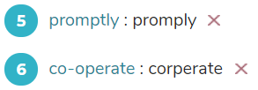不知道没有“-”算不算对

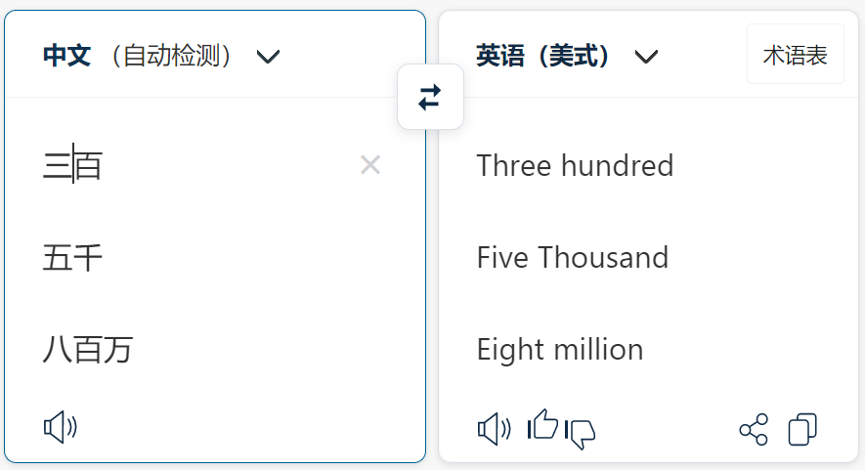 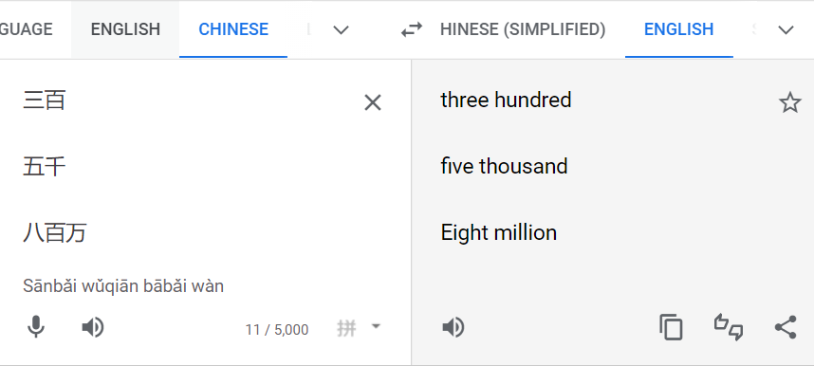

数字单位不用复数 Number units are not necessarily to be plural

**关键词** 听力关键词锁定

modern -> today prospect->aspect , look into -> address, withstand (忍受)-> prevent … from

Amused -> funny out of here(->leave) particularly(主要是) -> primarily

Linking -> attach **very often->regularly** Expensive -> does not come cheaply Linear notes -> notes in a line become(问题) -> turn into(原文) price -> bill

问题**allows** space for other animals(为其他动物提供空间)

听力原文other native animals are **given** space to increase their numbers also

**A wealth of -> many**

Based on -> the result of

**in anticipation of** (根据 预期)-> **consistent with**(符合 与什么一致)

**particularly quiet and introverted children** -> shy children

//13点05分 2022年3月1日 Next time read from below…

发音：

Drew -> draw

Shells(音80%似 shows), sealed 密封的

Sphere, containing -> spherical container

Shielding 屏蔽

a typed(音或types) cover letter

quote

A of B ，则B为重点。

**1、听全文(或者所选取的整段)**：先从头到尾的把文章完整的听一遍，不管听不听得懂，先过一遍，了解个大概讲述的内容，做到心中有数。

**2、接着逐句精听**，好多长难句一次听不明白的话可以多听几遍，尽量依靠自己听到的内容联系场景把文章听懂。实在不明白也要把读音听出来。这个步骤锻炼的是听力理解能力。

**3、读全文**：仔细听过之后应该对文章内容了解比较细致了，接下来**跟着文章一句一句进行跟读**，实在不明白的地方先模仿发音，然后对照听力原文，加深自己的记忆。这个步骤也可以和第一个步骤结合在一起做，为的是锻炼语音和记忆力，同时对口语也是有帮助的。

**4、听全文**：全部写完后再听一遍原文重新梳理听力内容以及框架。过一遍题目，看看自己当时为什么做错。

精读: matching 首二末

长难句 弃卒保帅 仅找主谓宾，不连读。

动名词 词性转换 精读

雅思写作：Task 2 要结合自己的亲身经历

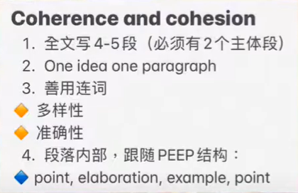 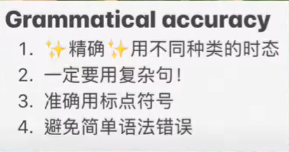

观点 阐述 举例 观点

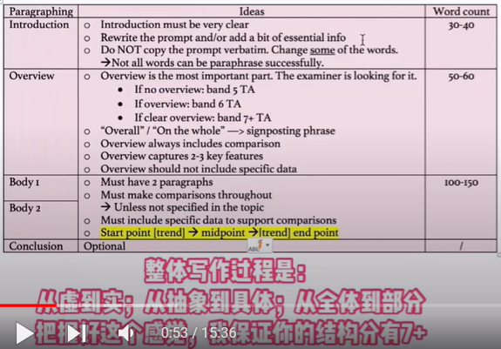 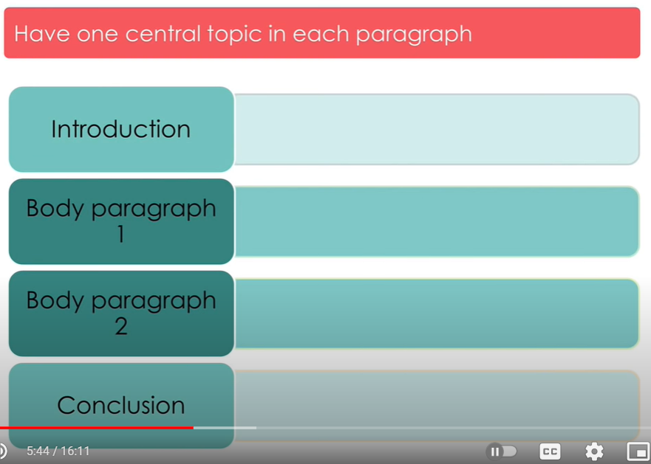

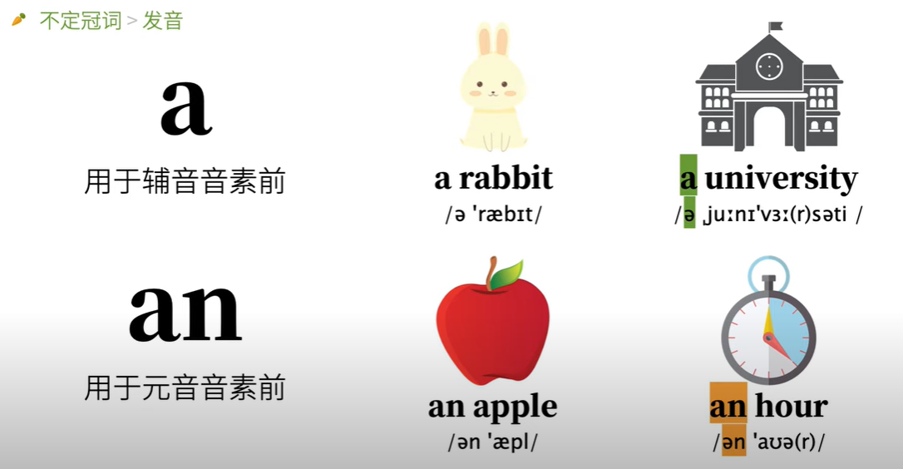 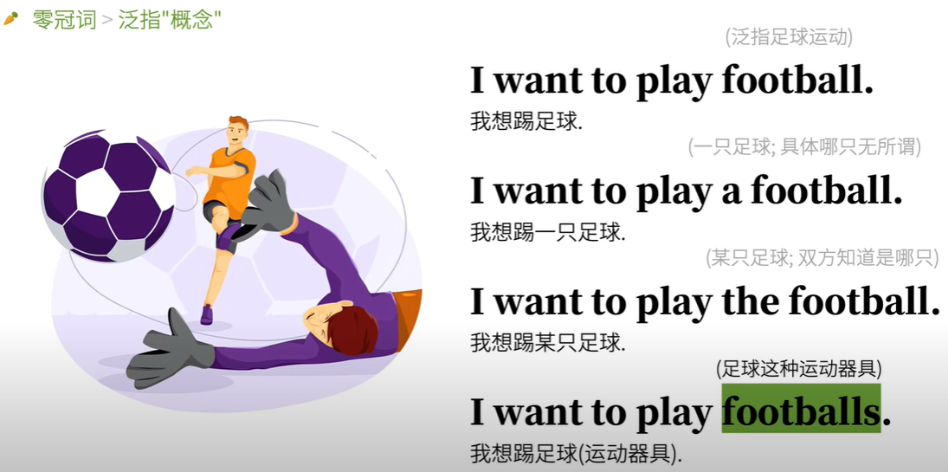

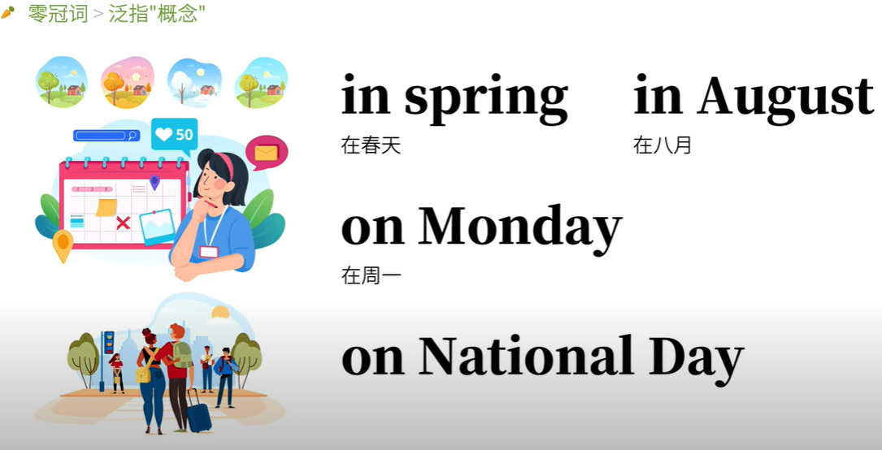 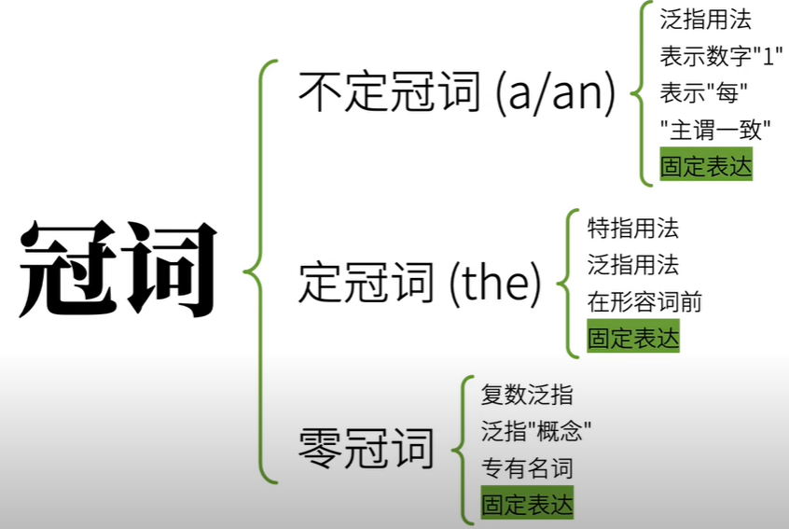

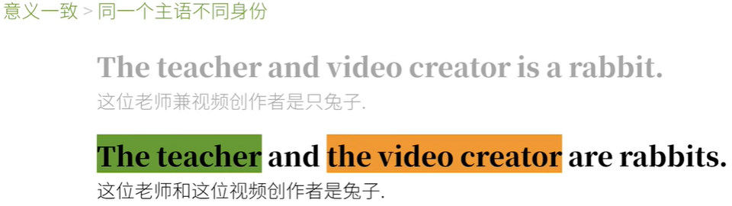

冠词的用法

零冠词复数泛指

If I want to mention a plural none generally, there should not be article THE.

Youtube writing tips summary 油管写作攻略：

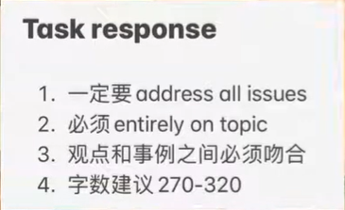 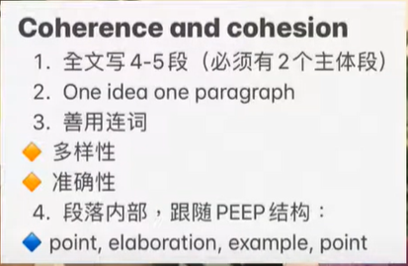 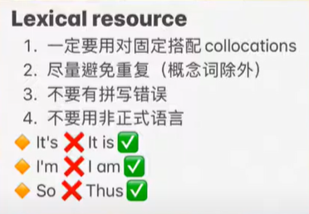 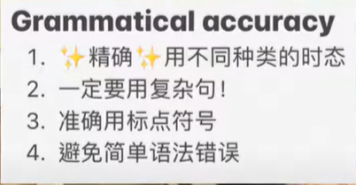

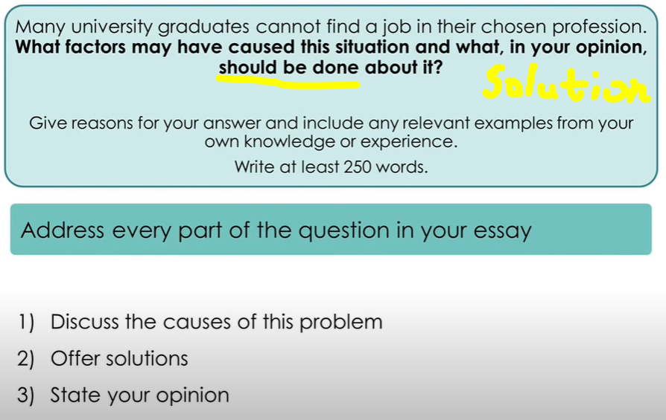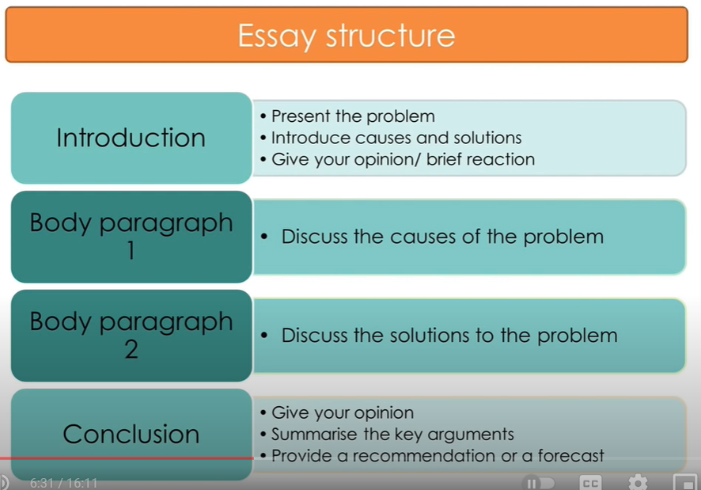

1.2. specific focus on the issue presented, on topic

2.3 Linking words 连接词: Be that as it may, However, Nevertheless

One the other hand 一定要和 one the one hand 连用

Despite his young age, he knows a lot. Despite + noun/noun phrase

把So 改成 Thus

In conclusion, in summary

**As a result**, the UK labor market **has** **an oversupply of** Laws or business graduates and **a deficit of** engineers. **因此**，英国劳动力市场上的法律或商业毕业生**供过于求**，而工程师则**短缺**。

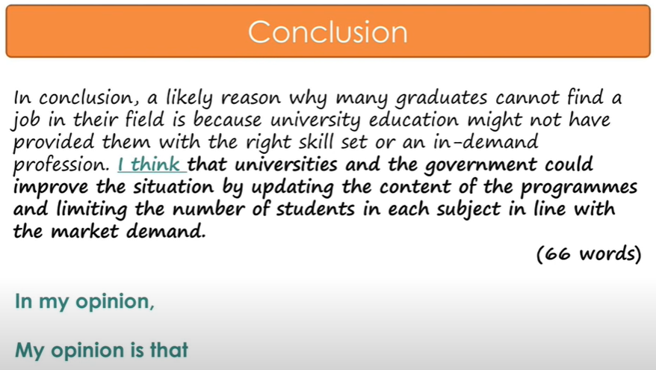

**3号明天反思task1 段落结构**

Foods 错误，因为它是不可数名词。

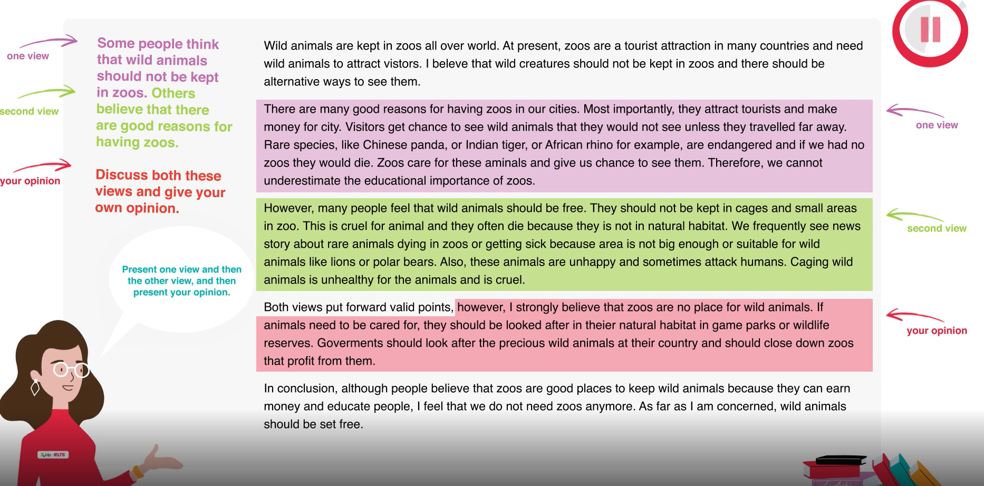

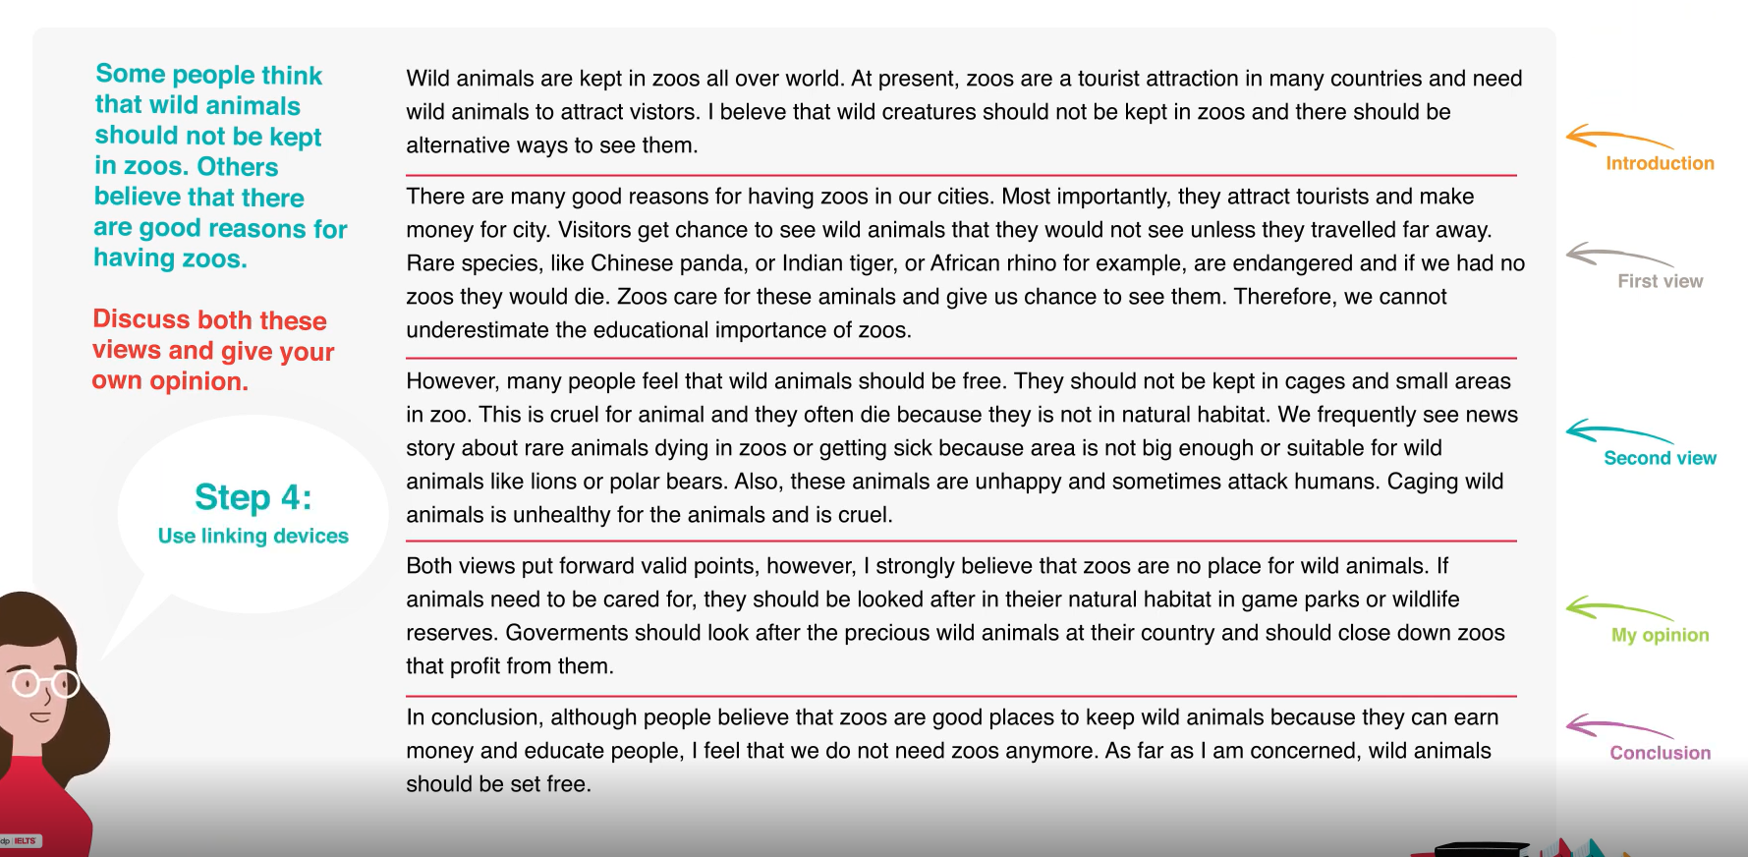

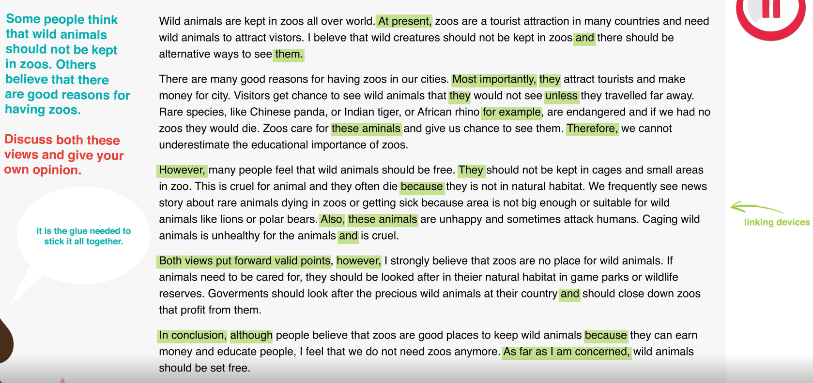

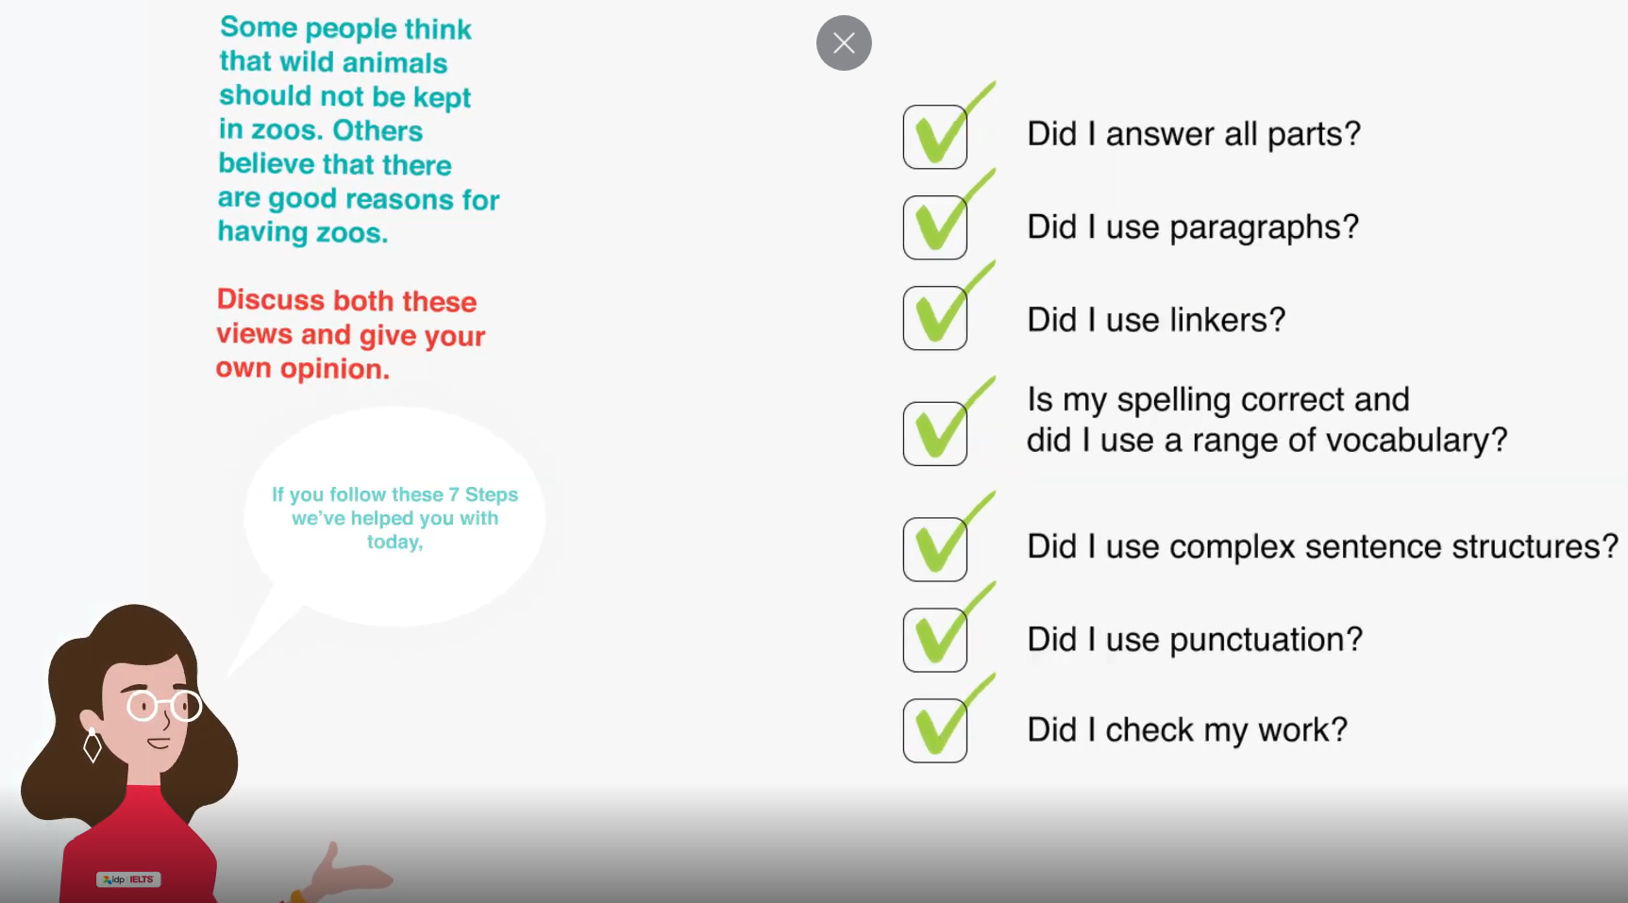 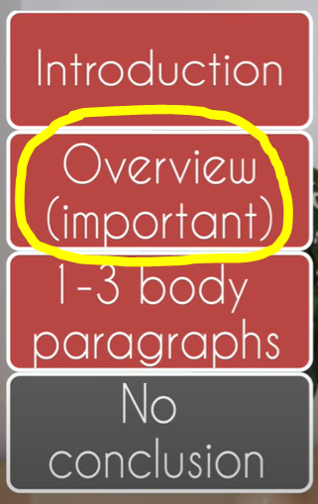

雅思口语:

口语 asked 时态 The**plural** of**Euro** is**Euro.**

even if 引导的从句是往往是假设性的，相当于汉语的“即使”“纵然”“就算”“哪怕”。

even though 引导的从句内容往往是真实的，主要用于引出不利用于主句情况的信息，相当于汉语的“尽管”“虽然”。

发音 familiar(否r蜜l里ar)

It sounds logical. 这听起来很合乎逻辑 这听起来很有道理。

Q8. I used to hike in a nearby national park. (Hike in not hiking)

I cannot **work out** what is important. 我无法**弄清楚**什么是重要的

I am quite an effective learner, but there are still times that I have to pull an all **nighter** to get things done. 我是一个非常有效的学习者，但有时我必须**通宵达旦**才能完成任务。

Sometimes I feel it's better to call it a day than to struggle for hours with no results.

有时我觉得，与其挣扎几个小时而没有结果，还不如结束一天的工作。

I guess the term **drill and kill** can best **portray** what most high school students in China are going through. 在考试中取得高分。 我想**操练和杀戮**这个词最能**描述**中国大多数高中生正在经历的事情。

Writing a high quality thesis required more than **number crunching**. 撰写一篇高质量的论文需要的不仅仅是**数字的计算**。

That subject contained many theories that were so **complex and abstract** that normal student had to spend hours to get **to grips** with them. **该学科包含许多复杂而抽象的理论**，以至于正常的学生不得不花几个小时来**掌握**它们。

Studying abroad would be a huge challenge, especially the language barrier, and I wasn't sure whether I was **up to it**. At that time, I was just a **mediocre** student who didn't **excel** in English at all. I got **cold feet** when I thought about studying a professional degree and having a life in English at the same time.

出国留学会是一个巨大的挑战，尤其是语言障碍，我不确定自己是否能**胜任**。那时，我只是一个**普通**的学生，英语一点也不**擅长**。 当我想到同时学习专业学位和以英语生活时，我感到很**冷漠**。

8.I've been longing to learn Spanish, which according to my knowledge is second only to Mandarin in terms of its number of native speakers worldwide.

9.I hope to be proficient in English because then I'll be able to enjoy British TV dramas without referring to the Chinese subtitles.

10.It wasn't easy at first, but gladly I am now **getting the hang of it**. 一开始并不容易，但很高兴我现在**掌握了窍门**。

I take my current job as a stepping stone to more challenging and rewarding jobs. Now that I've worked in the position for a long time and have improved my professional skills, I think I'm ready for something new.

Not knowing a second language puts them in a **vulnerable position** in the **fierce** job market. 不懂第二语言会使他们在**激烈的**就业市场中处于**弱势地位**。